**Chan, Luis [CHEN Fushan 陳福善] (1905-1995)**

Luis Chan was a doyen in Hong Kong art whose artistic career not only witnessed but also paved the way for the development of 20th Century Hong Kong art. Chan is well known in adopting different painting styles, and his curiosity in trying new things ultimately led him to establish his unique artistic style that marked the modernity of Hong Kong art. During 1920s until the 1950s, when Chan merely worked as a “Sunday painter”, he followed closely a conventional Western painting style; in particular the practice of outdoor sketching in watercolour influenced by contemporary British and American watercolourists such as Frank Brangwyn, J. M. W. Turner and John Sargent whom he admired. Executed in sketchy and bold brushwork, Chan was renowned for his quick sketching technique in watercolour landscapes, and it was this working manner and the huge quantities of works he produced that earned him the name of “Watercolour King” amongst artists in Hong Kong in 1950s. Since 1960s, Chan attempted develop a modern style of painting by borrowing from Cubism, Constructivism, Abstract Expressionism, Surrealism, and finally ended up developing an imaginative, fanciful and childlike style of his own.

Born in a Chinese family in Panama, Chan was a self-taught artist, with his art knowledge mainly acquired through reading art magazines from the UK. In the early 1930s, Chan met other local young artists such as Lee Byng (1903-1993) and Yee Bon (1903-1993) who had just returned to Hong Kong after their study in the Ontario College of Art in Toronto. From this time, these three artists became very close friends, and it was likely that Chan acquired his oil painting skill through practicing together with Yee and Lee.

Whilst Chan worked only as an amateur artist before the 1950s, he spent most of his spare time in outdoor sketching. Victoria Harbour, fishing boats and the cityscape of Hong Kong were recurrent themes in Chan’s watercolours. The rapid growth of Hong Kong since 1960s was perhaps an impetus to Chan in changing his painting style. Inspired by a French engraver whose works were shown in Hong Kong in early 1960s, Chan integrated printing techniques with his spontaneous drawing instead of copying directly from nature. Following the randomly printed colour patches on Chinese rice paper, Chan transformed them into fancy figures and dreamlike landscapes through imagination, and the outcome was an unprecedented hybridization of both traditional and modern, realistic and imaginative, Chinese and Western elements which was not seen elsewhere before.

Despite working as a very devoted amateur painter, Luis Chan was enthusiastic in promoting local art activities through organizing art clubs and exhibitions for other local artists. He was also an active art critic as his art reviews were often seen in local newspapers from 1930s to 1970s.

Chan’s playful attitude towards art is best described in his own words: “Throughout my career I liked to change, experimenting with new ideas and new methods. I would feel bored if ever I came to a standstill, painting the same old subject and the same old style again and again. One must keep on growing, evolving and creating!”

Luis Chan died on 25 June 1995, at the age of 95.

**List of works**

Lee, Sai Chong Jack (2006) *From Reality to Fantasy: The Art of Luis Chan*, Hong Kong: Asia Art Archive. (A comprehensive, lavishly-illustrated biography with well researched articles about Luis Chan by both Chinese and Western scholars).

*The World of Luis Chan* (2012), Hong Kong: Hanart TZ Gallery. (An exhibition catalogue that illustrates the late works of Chan with articles written by scholars and experts in Hong Kong art).

Chang, Tsong-zung (1985) *Happy Birthday, Luis Chan at Eighty*, Hong Kong: Hanart 2 (An informative catalogue with substantial amount of first hand biographical information about Luis Chan).

Hong Kong Museum of Art (1984) *Luis Chan: Fifty Years of Artistic Career*, Hong Kong: Urban Council. (An exhibition catalogue published by the Hong Kong Museum of Art with text in English and Chinese).

Hong Kong Museum of Art (1973) *Luis Chan: Retrospective Exhibition of Watercolours 1938-1962*, Hong Kong: Urban Council. (The first exhibition catalogue of Luis Chan published by the Hong Kong Museum of Art).

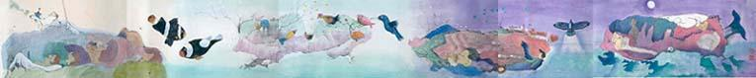

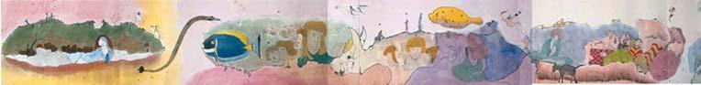



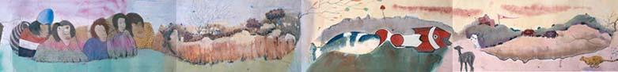



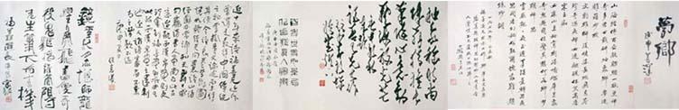

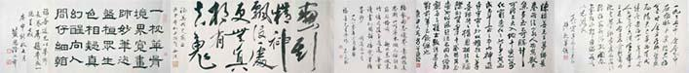

Luis Chan, *Dreamland*, 1979. Ink and colour on paper, handscroll. Hong Kong Museum of Art

<http://www.lcsd.gov.hk/CE/Museum/Arts/en_US/web/ma/collection08a.html>